**DX Spots Window**

# Hal Miller KB1ZQ, Geoff Anderson G3NPA, Jim Hargrave W5IFP, Aki Yoshida JA1NLX and Gerry Hohn VE6LB

## 1.0 GENERAL

The DX Spot window uses inputs from the Telnet Cluster window to display received DX Spots to display received DX Spots, and it handles max 300 to 1000 DX Spots. The number of max DX Spots can be specified in Logger32 Shortcut Properties.

This is a sample for max 300 DX Spots.

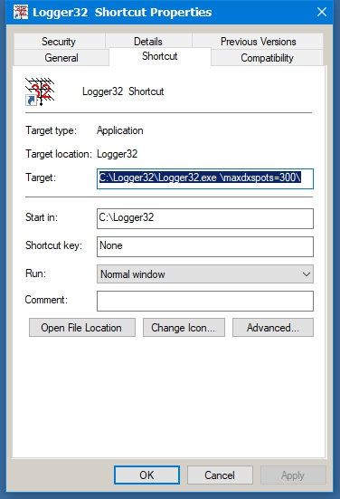

DXSW_40

**Note**: Information on how to send a DX spot to a cluster may be found in the Logbook Entry Window topic.

Operators with computer-controlled radios or CAT capabilities can also use this window to partially control their radios. By clicking on a spot, the radio will change frequency to the DX spot frequency and mode based on the operator's band plan allowing quick movement to a needed country or station. Then by right-clicking on the window one can go back to the original frequency by clicking on Reset radio frequency, this makes grabbing stations that pop onto the band easier. Please remember to verify the stations call before transmitting, as stations do move and another may have replaced the station you are looking for. With clusters being tied via the internet, spots are not always accurate.

**Note**: Clicking a DX spot while holding down the <**Shift**> or <**Ctrl**> keys now sends the DX spot frequency and mode to VFO-B of some SO2V-capable radios. This initial release supports a limited number of SO2V radio makes/models. If your radio did not make this initial release, please let Bob know the make/model and the command to set VFO-B's frequency and mode. It does not matter whether your radio actually has a second- or sub-receiver, just so long as it has two VFOs that can be commanded through the serial port. If you are operating SO2R, the same SHIFT or CTRL-click on a DX spot sends the spot frequency and mode to VFO-A of the non-focus radio.

Some or all of the entries in the table will be highlighted as the spots are displayed, with the information for this highlight being derived from the active logbook, for the selected operator(s) and for the QSL type. The user selects the operator and QSL type from a menu within the Worked Confirmed Window. The Dx Spot and Worked/Confirmed window title bars display that selection

The spots are displayed using the following columns, which are user-definable as to font, color and size (Grid Appearance):

* + **?** Worked before and LotW user columns;
  + **DX Spot** Call sign of the spotted station
  + **Pfx** Prefix or Country
  + **Freq** Frequency
  + **Comment** Free format comments
  + **Time** Time the spot was posted
  + **Origin** The originating stations callsign

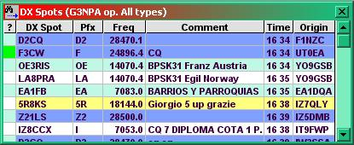

DXSW_1

The Freq format is selectable. Click Setup|DX spots in the main Menu and check your favorite frequency format. This format is used to send DX spots as well.

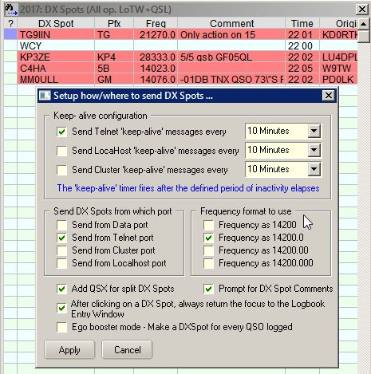

DXSW_1A

Configuring the DX Spot Window makes extensive use of multiple pop-up and linked menus.

Right-clicking on the DX Spot window displays a pop-up menu that provides the operator with various functions and access to additional pop-up menus.

Individual column widths in the DX spot table may be altered to suit the user by placing the cursor over the divider between columns in the title section, i.e., between DX Spot and Pfx or Comment and Time. The cursor will change to a double-ended arrow with a left-click, hold and drag will allow changing the size.

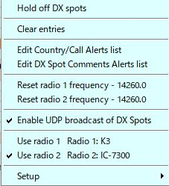

new DXSW_2

## 2.0  MAIN MENU

The Main menu items provide the following functionality:

### 2.1 Hold off DX Spots

This item is a toggle, and when checked, the display of incoming spots is disabled and the DX Spot window Title bar will display "On Hold". When un-checked, the display of incoming spots is again enabled and the title bar will revert to the normal "DX Spots" display.



DXSW_36

### 2.2 Clear entries

Clears all entries from the DX Spots Window.

### 2.3 Remove xxxxx DX Spot

If you have clicked on a specific DX spot, then this menu option will appear, allowing for the removal of that particular spot from the table and the map displays. In the example below, the cursor has been clicked on C5YK. Selection of this option will remove ALL occurrences of that callsign. This action also removes the spots from the DX Spot map and the appropriate band map (see the Band Map topic).

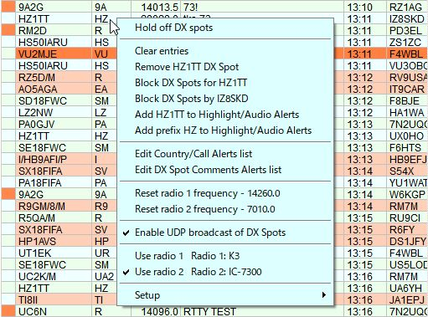

new DXSW_37

### 2.4 Block DX Spot for xxxxx

Listed DX callsigns will be filtered from the DX Spots window. To block spots for a callsign, right-click on the DX spot entry and then click on "Block DX spots for xxxxx" and the callsign will be entered into the appropriate list. See also the paragraphs on Blocking Filters towards the end of this topic.

### 2.5 Block DX Spots by xxxxx

DX Spots FROM the listed callsigns will be filtered. To block spots from a callsign, right-click on the DX Spot entry and then click on "Block DX Spots by xxxxx" and the callsign will be entered into the appropriate list. See also the topic on Blocking Filters towards the end of this section.

### 2.6 Highlight/Audio Alerts and Alerts List

2.6.1 Add xxxxx to Highlight/Audio alerts

Add the DX Callsign of the selected DX Spot to specific callsign list for Highlight/Audio alerts.

### 2.6.2 Add prefix xx to Highlight/Audio Alerts

Add the prefix of the selected DX Spot to specific prefix list for Highlight/Audio alerts.

### 2.6.3 Edit Country/Callsign Alerts list

Show Edit Country/Callsign Alerts list.

### 2.6.4 Edit DX Spots Comments Alerts list

Show Edit DX Spots Comments Alerts list. Details are described in 2.9.5 Alerts.

### 2.7 Reset radio 1 (or 2) frequency

Resets the radio (either #1 or #2) to the last frequency used, prior to selecting a spot. For example, you are on a net frequency when a needed country pops up on another frequency or even another band. Click on the spot to change bands/frequency, work the DX station, then click on Reset radio frequency and you will be returned to the original net frequency. Of course, this function does require a radio that is controlled by Logger32.

The menu item will show the frequency to which the radio will be reset.

### 2.8 Enable UDP broadcast of DX Spots

### Logger32 broadcast DX Spots displayed in DX Spot Window via UDP port 12061 for external program. This is a sample where external test program displays DX spot broadcasted by Logger32.

### DXSW_37A

### ~~2.8~~ 2.9 Use radio 1 or 2

Allows the user to manually switch the "active" radio. The check mark will confirm which radio is "active".

### ~~2.9~~ 2.10 Setup Menu

The Setup menu item displays an additional pop-up menu that provides the operator with the ability to select four more pop-up menus and three additional functions.

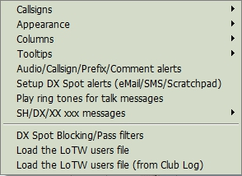

DXSW_3

### ~~2.9.1~~ 2.10.1 Callsigns

This pop-up menu, allows the user to display yet another pop-up menu in order to set the call signs to be used by the Telnet & Cluster and Local Host Tab Panels of the Telnet Cluster window and Data Terminal window.

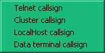

DXSW_4

Clicking on any one of the selections will display a dialog box, allowing the user to enter a callsign to be used for the selected tab panel or Data Terminal window.

### ~~2.9.2~~ 2.10.2 Appearance

This menu allows the user to select different color schemes and message selections to "individualize" the DX Spots window

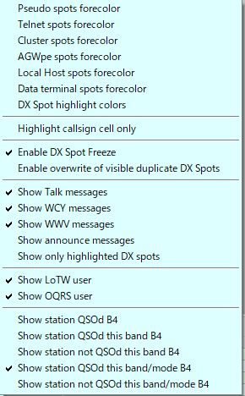

DXSW_5

**Colors**

Selecting Pseudo, Telnet, Cluster, or Data Terminal spots foreground color displays a color selection box that allows the user to select individual forecolors for the connection being posted.

**DX Spot highlight colors**

Selecting the Worked / Confirmed/Credited colors opens a window that sets the background colors to be used in the DX Spot Window for each spot that meets the specified selection. The color displayed is based on the user's Band Plan to determine bands and modes. The color selection is made using a standard Windows Color Dialog Box, by clicking on the color to be selected.

The one exception to the above is the selection of the LoTW/OQRS/LoTW & OQRS user color. In this case the highlight is applied to the "?" (leftmost) column in the DX Spot Window.

The details of syntax and logic to highlight is explained in paragraph 2.9.5 Alerts.

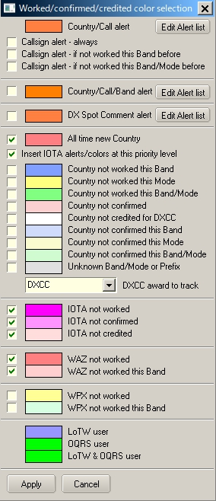

DXSW_6

For Country/Callsign alert, clicking “Edit Alert list” shows an Edit list of Callsigns to highlight table.

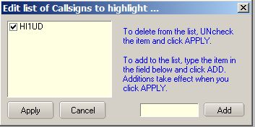

DXSW_6A

For Country/Call/Band/ alert, clicking “Edit Alert list” shows Setup Conditional Country Alerts table. Check Edit this alert box to start edit. See details in the paragraph Alerts.

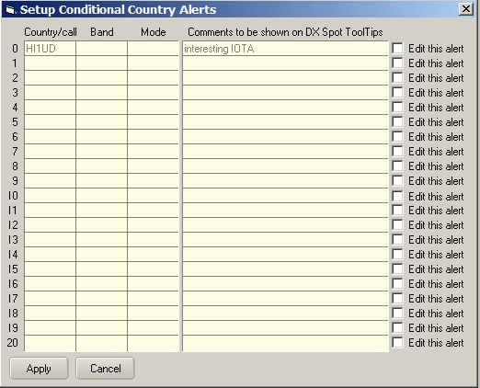

DXSW_6B

For DX Spot comment alert, clicking “Edit Alert list” shows Edit list of Comments to highlight the table.

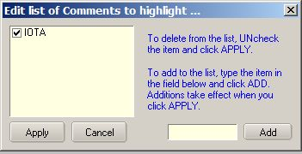

DXSW_6C

The check boxes to the left allow the user to determine which, then they can simply uncheck that color selection.

The entry 6 from the top of the table is determined by the selection made in the pane below the entry for unknown band/Mode. In this case particular example the highlight colour depicts "Country not credited for DXCC_MIXED". Note that "Credited and Confirmed" are not the same thing. "Confirmed" indicated that you have received confirmation in some form from the qso partner. "Credited" indicates that the contact has been adjudicated and included in your credits for the award in question.

The check option second from the top will give the option to insert the IOTA not worked/confirmed/credited highlight colors into the priority search at that level. If checked, Logger32 will highlight in the order New Country; IOTA not worked; IOTA not confirmed; IOTA not credited: Country not worked this band etc. etc.

See also the topics Award Tracking and Show only Highlighted DX Spots.

Audio alarms and DX spot highlight coloring has been introduced for IOTA spots. As a byproduct of this code, changing the IOTA field in the Logbook Entry Window (either manually, or auto-populate) will show IOTA Want/Need status in the second pane (from the left) of the upper status bar (only if there is no DX Want/Need text displayed), as can be seen in the example below. Want/Need messages and highlight colors have the following precedence:

* + DX;
  + IOTA, and;
  + WPX Want/Need

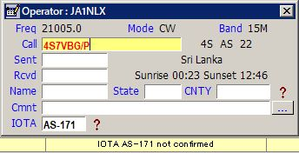

DXSW_7

**Highlight callsign cells only**

Changes the general row highlighting to cover the callsign column only

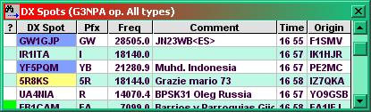

DXSW_8

### Enable DX Spot Freeze

Mouse wheel or scroll bar activity, freezes incoming spots for 10 seconds in DX Spot Window. This should be enough time for the user to browse the history and click on a line. Following a mouse click, the freeze is canceled. During this freezetime, incoming spots are suppressed.

During the period that the software holds off incoming spots Title bar changes to display the fact that a "Freeze" is in effect. The series of dots following the word "Freeze" will display a count down to the freeze being released automatically if no further action is taken.

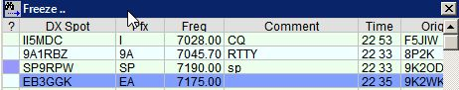

DXSW_39

Those using a mouse configuration where Windows does not see mouse wheel events can simply scroll using the scroll bar

**Enable overwrite of visible duplicate DX Spots**

This option enables/disables the overwriting of duplicate DX Spots that are visible on the DX Spot Window.  The default is enabled.  As before, duplicate DX Spots that are visible on the DX Spot are simply overwritten with data from the new DX Spot.  If this option is disabled, then when a duplicate DX Spot is received where the original DX Spot is still visible on the DX Spot Window, the old DX Spot is removed and the new DX Spot is added to the end of the DX Spot Window

**Show talk messages**

Talk messages will be displayed in the DX Spot window.

**Show WCY messages**

WCY messages will be displayed in the DX Spot window.

**Show WWV messages**

WWV messages will be displayed in the DX Spot window.

**Show announce messages**

Announce messages will be displayed in the DX Spot window.

**Show only highlighted DX spots**

In the Appearance menu selection the user can select which DX Spots to have highlighted. This menu selection goes one stage further and will remove from the DX Spot list any non-highlighted spots. The screenshots below show the effects of both menu items:

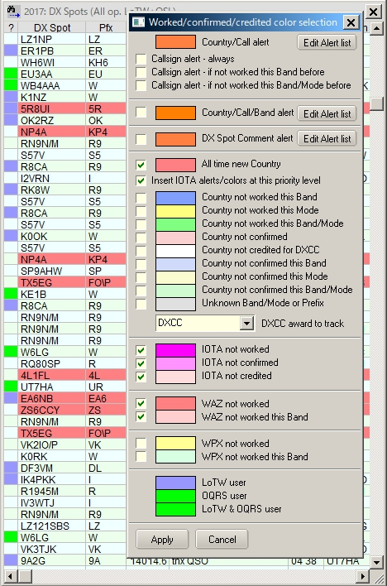

DXSW_9

Almost all background colors selected.

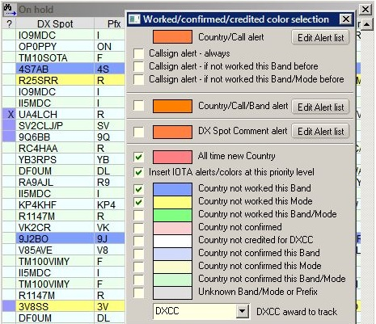

DXSW_10

This screenshot shows the effect of only having four background colors selected. The spot data is the same as above. Note that non-highlighted spots still display in the listing

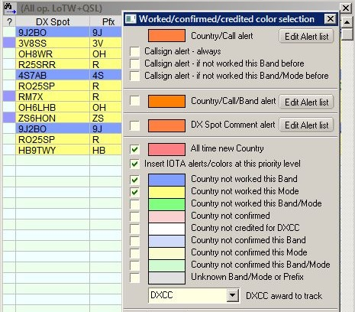

DXSW_11

This screenshot shows the effect of selecting the Show only highlighted DX spot menu option. Now only highlighted spots are displayed.

**Show LotW user and Show OQRS user**

Here the user can select to display if the station is known to be LotW user and/or OQRS user. This is indicated by a highlight color in the (leftmost) column of the DX Spot table

To choose the LoTW and OQRS user highlight colors, Right click on the DX Spot Window, Left Click SETUP | APPEARANCE | DX SPOT HIGHLIGHT COLORS.

To enable/disable LoTW and/or OQRS user highlights on the DX Spot Window, right click on the DX Spot Window, then left click SETUP | APPEARANCE | SHOW LOTW USER and/or SETUP | APPEARANCE | SHOW OQRS USER.

To enable/disable LoTW and/or OQRS highlights on the Band Map Windows, Click CONFIG | SHOW LOTW USER.

**Show station QSOd before**

Here the user can select to display if the station has been worked before. This is indicated by an "X" in the "?" column of the DX Spot table

The user has four options to show:

* 1. Stations QSOd before on any band
  2. Stations QSOd before on the particular band
  3. Stations QSOd before on the particular band/mode combination, or
  4. None (Uncheck the options).

In the screenshot shown below it can be seen that 9K2ZZ has been worked on 20m but not on 40m. The colored highlight in the "?" column also shows that 9K2ZZ is a user of LotW.

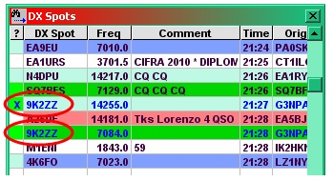

DXSW_12

**A word of warning.**

These options use information contained in the bandmode.db file and in the log to derive the "Worked before" marker. Under contesting type conditions, the band plans usually are not adhered to so an incorrect mode might be determined by the software for a particular spot and hence not mark the callsign correctly if the band/mode option is used.

### ~~2.9.3~~ 2.10.3 Columns

The four main items are toggles that, when checked, display the specified column in the DX Spot window. If a menu item is not checked, that column is not displayed.

The Show full country name option will change the Pfx column header to read "Country" and the column will fill with the full names of the country.

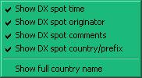

DXSW_13

### ~~2.9.4~~ 2.10.4 Tooltips

The Tooltips selection opens a panel that enables the operator to customize Windows Tool-Tips. When the cursor is placed over a callsign in the DX Spots column, the country prefix, country name, CQ Zone, continent, status of the country (needed on band, new country, not confirmed), status of IOTA (not worked, not confirmed, not credited),status of WAZ (not worked, not worked on this Band), status of WPX (not worked, not worked on this Band), and the elapsed time the spot has been posted will be displayed as a Windows Tool-Tip as selected.

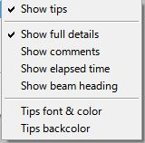

DXSW_14

If you set any text in Comments column of Setup Conditional Country Alert table then this text is displayed. See DXSW_6B or DXSW_15AA

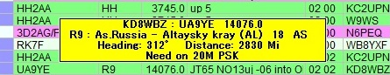

DXSW_14A

**Show full details**

With this line checked the tool tips become more informative. They will provide the spotter's call, call of the spotted station,  and frequency of the spot on the first line. The second line will show the prefix of the spotted station, the country, CQ zone, and continent. The third line, if any, will state the operator's need for the spotted station, i.e., Need on 17m.

If this line is not checked then only the prefix of the spotted station, the country, CQ zone, and continent. The second line, if any,  will state the operator's need for the spotted station, i.e., Need on 17m.

**Show elapsed time**

With this option checked the tooltip will contain the time elapsed since the DX spot was reported

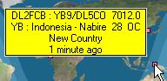

DXSW_15

**Tips font & color**

Sets the tool tips font and color using Windows standard font setup box.

**Tips backcolor**

Sets the back color of the tool tips box displayed using Windows standard color selection box.

Tips font, color and backcolor setting affects appearance not only in tips in DX Spot Window but in all other tips in Logger32.

### ~~2.9.5~~ 2.10.5 Alerts

**Enable audio alerts**

In this pop-up menu, the different audio alerts can be selected to sound when individual audio WAV files used in the DX Spots window for each spot that meets the specified selection. The WAV file played is based on the user's Band Plan to determine bands and modes. Selections will only play when the small box is checked.

**Audio alert for callsign(s)**

This allows the operator to be alerted for a particular station. For example, if the operator is looking for KC4AAA, they would enter that call into the field, along with others separated by commas. When the spot appears, the audio alert will sound.

This syntax and logic are used for DX Spot highlight color for Country/Callsign as well. See Operational notes below also.

* + Full callsign - G3NPA, K4CY, etc
  + Full prefix - P5, VP8\SH, etc
  + Callsigns beginning with - UA9V*, UA9X*, etc
  + Callsigns ending with - *CY, *NPA, etc.
  + Partial callsign - *2008*

If an exact callsign match is found and if it also matches the users settings of a) Always, b) Not worked this band, or c) Not worked this Band/Mode, then audio alert (or highlight color) is applied.

If a prefix or partial callsign match is found and if it also matches the users settings of a) Always, b) Not worked this band, or c) Not worked this Band/Mode, then audio alert (or highlight color) is applied

Click “Edit Callsign Alert list.”

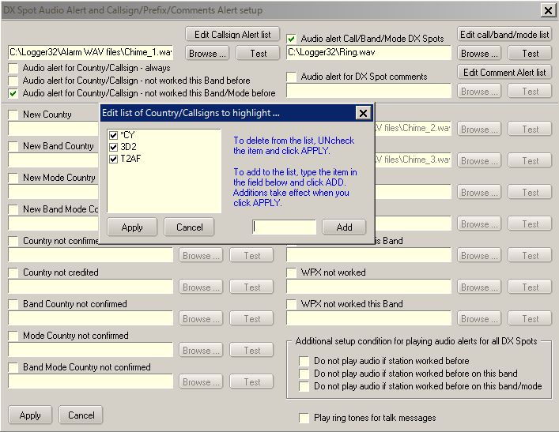

DXSW_15A

**Operational notes**:

**Note 1**. Audio alerts are NOT played if transmitting using the sound card.

**Note 2**. Wild card options 4 must be used judiciously. Take the example given of *CY - The bells will ring if the callsign contains the letters CY, so the following match - CY0XX, K4CY, K4CYA, etc.

**Note 3**. Callsign Audio alerts must be enabled by checking one of the three options at the top of the chart. These selections will take precedence over other Audio alert settings for the listed callsigns.

The order in which the audio alerts are determined cannot be changed; however, while the order of priority cannot be changed, the user can now eliminate items from the list (by unchecking items). For example, uncheck New Country - this Band, New Country - this Mode and new Country - this Band and Mode, the order becomes:

* + All time new Country
  + Not Confirmed
  + Not confirmed, this Band
  + Not confirmed, this Mode
  + Not confirmed, this Band/Mode
  + Unknown

**Note** that using the above example will still effectively show up those band/mode combinations not worked - for if not worked they can't be confirmed!

Audio alerts can be suppressed by selecting one of the options listed in the lower right hand corner of the DX Spot Audio alert setup chart. Use these new options, to suppress audio alerts if a station is worked/band/mode.  All audio alerts except callsign alerts and comment alerts will be suppressed.

**Audio alert for Call/Band/Mode DX Spots**

Click “Edit call/band/mode list”

The Country/Call field looks for a Prefix match (remember, Logger32 uses a \ as in VP8\F), a callsign or partial callsign, or a DXCC Country number. Wild cards are accepted

 The Band field can be empty (any Band) or a Band recognized by Logger32. The DX Spot Band is calculated from the DX Spot frequency and the users BandPlan.

The Mode field can be empty (any Mode) or a mode recognized by Logger32.  The DX Spot Mode is derived from the best information in the DX Spot.  A skimmer DX Spot, a Mode in the Comments field, or as a last resort, the mode from the users BandPlan.

The Comments column is optional and can be used for user personal reminders for the purpose of the alert and can be seen as the bottom line of the DX Spot ToolTip Window.

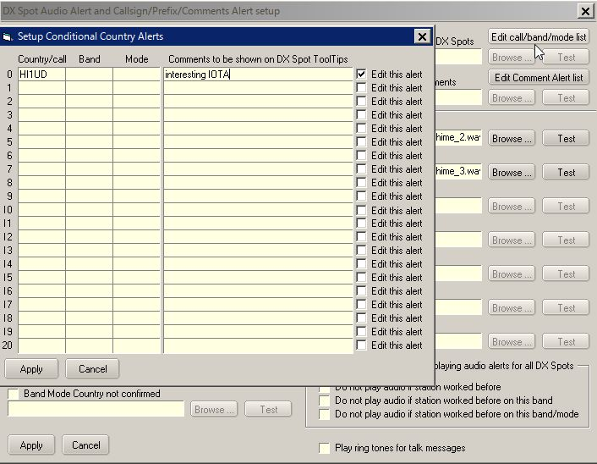

DXSW_15AA

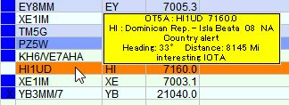

DXSW_15AB

**Audio alert for DX Spot comments**

This allows the operator to be alerted when certain text is detected in the DX Spot Comments, such as contest and modes. Click “Edit Comment Alert list.”

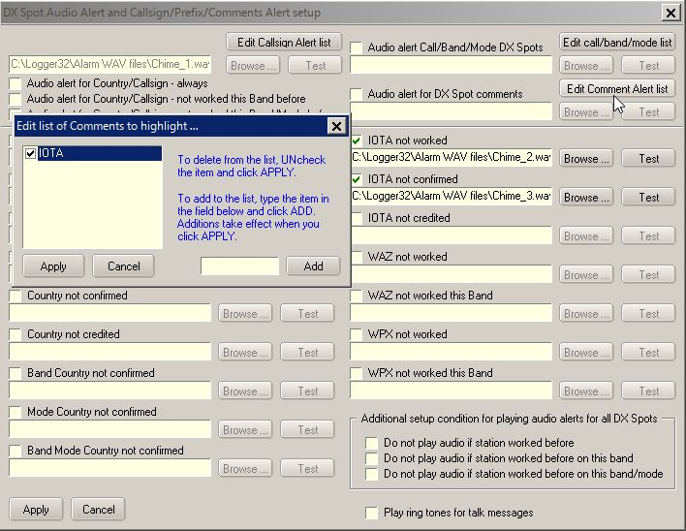

DXSW_15B

**Audio alert for IOTA**

Three alert categories of IOTA are available for user selection.

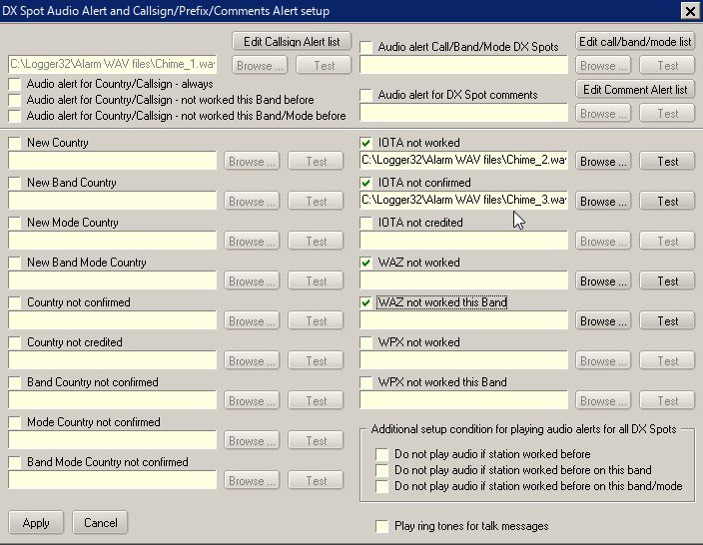

DXSW_15C

**Audio alert for WPX**

Two alert categories of WPX are available for user selection.

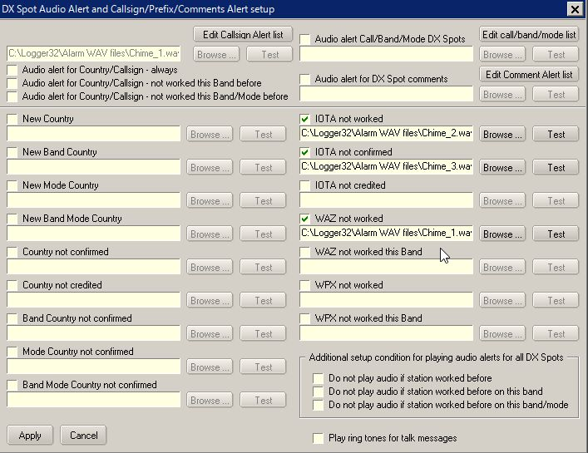

DXSW_15D

**Additional setup condition for playing audio alert for all DX Spots**

The next three items are toggles which, when checked activate the following functions. If an item is not checked, that function is not available.

**Play Ring tones for TALK messages**

This menu selection is a toggle. When checked, a file called RING.WAV is played to give a telephone style "ring tone" whenever a "talk" message is received from the DX cluster.

1. **~~2.9.6~~ 2.10.6 Setup DX Spot alerts (eMal/SMS/Scratchpad)**

You can receive eMail alerts when your interested DX is spotted. The default setting is for Gmail.The Gmail security is set to allow less secure apps to access Gmail.  Go to <https://www.google.com/settings/security/lesssecureapps> and turn it ON.

Click eMail alerts to open the Setup table. Put your Gmail address, Gmail password and optional address where Gmail is to send the alert email. Do not change your Outgoing SMTP mail server and Outgoing SMTP port if you use gmail. Click Apply.

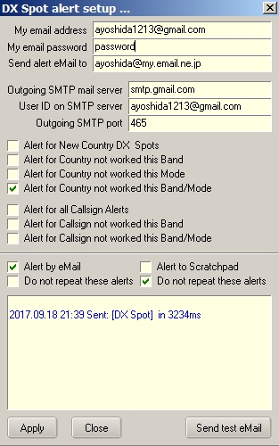

DXSW_16

Logger32 shows the DX spot which is sent to Gmail in lower area in this table and writes the same data in the mailLog.txt in the Logger32 folder.

Send email to New Country DX Spots, Send eMail for country not worked this Band, Send eMail for country not worked this Mode and/or Send eMail for country not worked this Band/Mode:

If checked then Logger32 sends the spot to Gmail.

Send email for Callsign Alerts, Send email for not workd this Band Callsign Alerts or Send email for not worked this Band/Mode Callsign Alerts:

If checked and callsign to be alerted is specified in DX spot audio alert setup table then Logger32 sends the spot to gmail.

**Note**: These are independent from Credited/confirmed/worked color on/off setting or DX spot audio alert on/off setting.

If you have no gmail account then you may use your regular email account. Put Outgoing SMTP mail server and Outgoing SMTP port. There may be server which asks you to send a User ID different from the email address. This is another setup example..

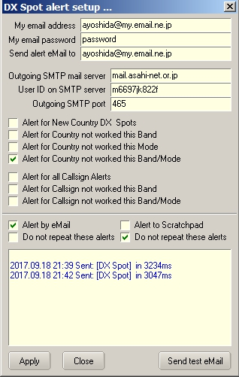

DXSW_16A

### ~~2.9.7~~ 2.10.7 SH/DX/XX xxx Messages

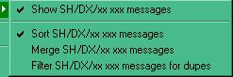

DXSW_17

Here's how it's supposed to work:

**Show SH/DX/xx xxx messages** - This simply turns on/off the sending of SH/DX messages to the DX Spots Window.  With this option unchecked, the options below it have no effect. This gives the capability of NOT showing DX Spot information from an SH/DX/xx command sent to a cluster in the DX Spot Window. This is for those who want to collect the info in the telnet window but not have the information mess up the DX Spots list.

**Sort SH/DX/xx xxx messages** - With this option checked, and the Show SH/DX/xx xxx option checked, messages from a user command SH/DX are sorted in chronological order and appended to the bottom of the DX Spots Window.

**Merge SH/DX/xx xxx messages** - With this option checked, and the Show SH/DX messages option checked, messages from a user command SH/DX are sorted (regardless of the Sort SH/DX option setting) and merged into the entries already in the DX Spots Window.

**Filter SH/DX/xx xxx messages for dupes** - If this option is checked, and the Show SH/DX messages option checked, duplicate messages are filtered and not sent to the DX Spots Window.

Note: If Show SH/DX messages option is checked, and no other option is checked, the resulting messages from a user command SH/DX/xx xxx is appended to the DX Spots Window as received from the Telnet/Cluster (in reverse chronological order, as it was originally.).

### ~~2.9.8~~ 2.10.8 Blocking Filters

This allows DX spots from an originating continent, to a destination continent, by band or mode to be blocked. For example, an operator not wanting to see spots from Europe, due to a European contest, can block all spots from Europe by selecting the Originating Continent Tab and checking the small box next to Europe. If an operator does not have the capabilities for 6 meters they can go to the Band tab and check the 6 meter box and block those spots. In addition the DX, Originator and Comments filters will allow for further specialised filtering.

If the bands or modes you want to block are not listed in the Band or Mode lists then the Band/Mode table must be edited to add these bands and modes. In other words, if the band/modes are missing, make sure that these bands and modes appear in the BandMode table. If users do NOT want award stats to show because these are being introduced, then mark the BandMode table with an "N: in the Stats column for these new entries.

**~~2.9.8.1~~ 2.10.8.1** In the example below, only DX spots originating from Europe are of interest.

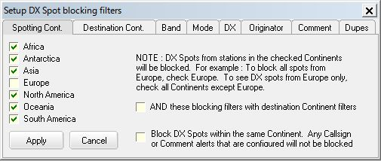

DXSW_18

**~~2.9.8.2~~ 2.10.8.2** If you want to block DX Spots within the same Continent (NA spotting another NA station, SA spotting another SA station, etc.)

DX Spot Callsigns (or prefixes) and DX Spot Comments that are configured to trigger Alerts are not blocked. This option can be checked under either Spotting Cont Tab or Destination Cont Tab.

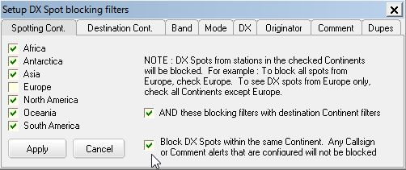

DXSW_18B

**~~2.9.8.3~~ 2.10.8.3** if you want to see all destinations

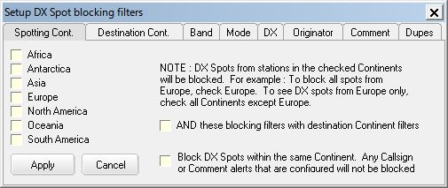

DXSW_19

**~~2.9.8.4~~ 2.10.8.4** In the example below, DX spots originating from North America AND to destination North America are blocked.

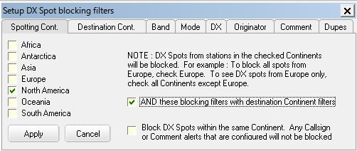

DXSW_18A

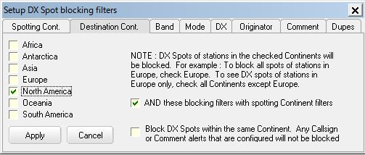

DXSW_19A

**~~2.9.8.5~~ 2.10.8.5** or possibly any annoying Mode and/or DX callsign

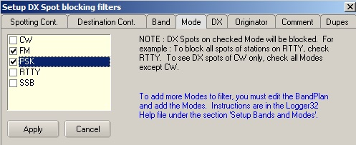

DXSW_19B

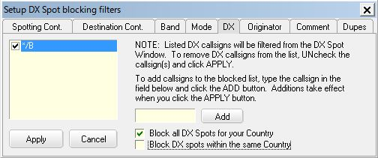

DXSW_22

**~~2.9.8.6~~  2.10.8.6** The Block DX Spots by Callsign feature will accept wildcards

* + - Adding a callsign of K4* will block all DX Spots that have a callsign starting with K4.
    - Adding a callsign of */B will block all DX Spots that have a callsign ending with /B.
    - Adding a callsign of *XX* will block all DX Spots that have callsigns containing XX.

**~~2.9.8.7~~ 2.10.8.7** If Block DX Spots for country that matches Current Operator is checked then all DX spots Spots for country that matches current operator are blocked.

If you want to block DX Spots that are within a Country (an I making a DX Spot of another I, an EA making a DX Spot of another EA, etc.).

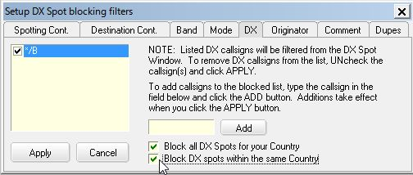

DXSW_22A

Example: If current operator is JA1NLX then all DX Spots for JA are blocked, or even an originator self-spotting!

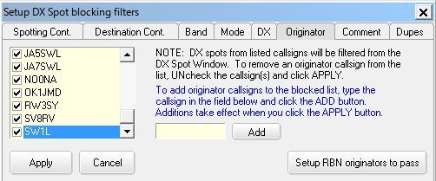

DXSW_23

Note that ALL the parameters set through these option windows are remembered between Logger32 sessions and will remain in force until changed or deleted.

**~~2.9.8.8~~ 2.10.8.8** If you want click “Setup RBN originator to pass” button.Type originator’s callsign and click “Add” button. The callsign is listed with “-#” at the end of the callsign. Finally click “Apply” button to make changes effective.

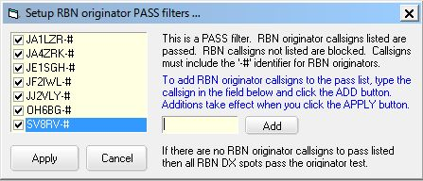

DSXW_23A

**Application note from Gerry VE6LB:**

Some of you may wonder what the new RBN (Reverse Beacon Network) “Pass filter” is useful for. I’ll try to give you some idea of how to use it.

I’ve found that fewer and fewer people post spots of stations calling CQ on CW and RTTY, especially during contests. Why? Simply, the global RBN network and local skimmers post CQ’er heard much faster than any individual spotters. Many traditional clusters now integrate “real” spots with RBN/skimmer spots if the “Set/Skimmer” command is issued to them.

The problem is the flood of RBN spot one receives even with the Logger32 filters set to something like NA. This new feature can be set to only show you spots from skimmers located near you.

Simply leave you current filter settings as they are and in the “Originator” tab select Setup RBN Originators to Pass and fill in skimmers in your area. Just the call as Logger32 will add the –#. Since skimmers and skimmer servers vary in what the block (like dups and broken calls), some experimenting may be required.

The “apply a little sanity.......” option in under the “Dupe” tab should likely be Unchecked as it look for a number of incoming spots with the same information before doing an actual spot. If the skimmer/server is already taking care of this, you could miss that rare one you’ve been looking for since dups will not get to Logger32.

I want to know which spots are “real” and which were from the RBN so I have 2 network connection. One to the normal packet network with skimmer (VE7CC in my case) turned of and a second to the RBN Wholesale server (telnet.reversebeacon.net) using the Local Host tab. There are likely other RBN servers that will work fine. I then select a different color in the DX Spot window for RBN spots by a right click/setup/Appearance/Local Hosts spots forecolor.

**~~2.9.8.9~~ 2.10.8.9 Remove bullshit from DX Spot comments field**

Click Setup DX Spot comment filters

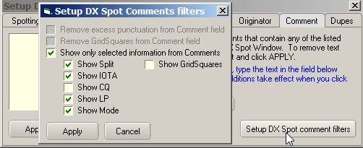

DXSW_23B

Remove excess punctuation from Comment field:

(((((, ))))), !!!!!, are removed. CQ CQ CQ is replaced by CQ, ????? is replaced by ? etc

Remove GridSquare from Comment field:

GridSquare is removed

Show only selected information from Comments:

If this option is checked then options above are unchecked. Only selected information are displayed in Comment field. This is an example of DX Spot window when “Show only selected information from Comments” is checked with some items selected like above.

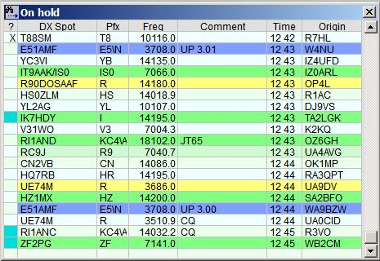

DXSW_23C

**~~2.9.8.10~~ 2.10.8.10** Even spots with annoying comments can be removed.

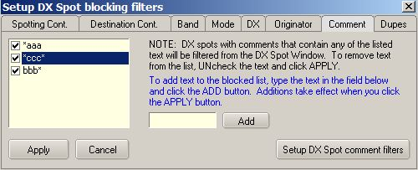

DXSW_24

**~~2.9.8.11~~ 2.10.8.11** Comment filtering is not case sensitive and wild cards may be used. Filter text may NOT contain a comma.

Examples:

* + - *text for comments ending with the text
    - text* for comments beginning with text, and
    - *text* for comments containing text.

**Beware** - if you simply use the "*" symbol on its own, ALL DX spots will be filtered out and nothing will appear in the list. Use this with caution !

**~~2.9.8.12~~ 2.10.8.12** This will allow display of multiple spots for DX Expedition?s and contest stations operating different modes on the same band while blocking dupes for the same operation.

A duplicate spot is not simply discarded. It overwrites the older entry in the DX Spot Window. As the DX Spot Window is sorted chronologically, the most current/recent DX Spots always have visibility.

Having both "Block duplicate RBN Spots" and "Block all duplicate DX Spots" does nothing but waste a lot of CPU cycles. Unless you have specific need to block RBN spots and not Telnet/Cluster Spots, then you should only check the Block all DX Spots option.

Apply a little sanity to Skimmer originated DX Spots. Checking this option does two things:

* + - Only the third skimmer spot for a station is processed - this attempts to remove the numerous false/bogus skimmer generated callsigns, and
    - After the third DX Spot for a station is processed, that callsign will not be accepted for processing for 60 seconds, and only after passing the test described in 1 three times.

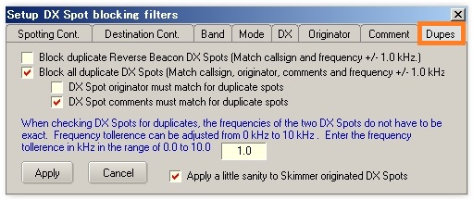

DSXW_25

**~~2.9.8.13~~ 2.10.8.13 Logic for DX Spot Dupes. (K4CY)**

DX Clusters works something like this ... Any time someone goes to a shipping hazard there is an unwritten rule that EVERYONE must make a DX Spot to confirm their QSO (sort of rite of passage for the DX’er). As a result, there is a constant blizzard of DX Spots.  A significant number completely bogus, and countless others on the completely wrong frequency.

Now, In Logger32, you can turn off duplicate DX Spot filtering.  Each DX Spot for the shipping hazard will be appended to the bottom of the DX Spot Window (chronologically)

If however, the user has duplicate DX Spot filtering enabled, then the following (or something like this) happens ... If the previous DX Spot is no longer in the visible part of the DX Spot Window, the original is deleted from the list (you can't see any change) and the new DX Spot is appended to the bottom of the list. The list simply scrolls up smoothly.  This procedure is not applied to DX Spots that are currently visible because would be very distracting to watch the list constantly shuffling the list as visible DX Spots are being removed from the list to be replaced by duplicate ones at the end.  So, in Logger32, the old visible DXSpot is simply overwritten (wherever it is in the visible list) with the new one.

I can assure you that the scenario I described of removing Visible DX Spots and adding the duplicate DX Spot to the end of the list is indeed VERY distracting.  Like trying to read the manufactures name on an accordion while it is being played.   Otherwise I would not have gone to the trouble of implementing the much more difficult code that simply overwrites the visible original DX Spot with its duplicate.

### ~~2.9.9~~ 2.10.9 Load LotW user file

This gives the ability to download and create or update the user-selected database in the default Logger32 directory. This facility allows download of any suitably formatted file from the Internet or users archives.

Logger32 defaults to the LoTW user file. This file contains only LoTW user callsign. The following examples show the process for LoTW update and are representative of the process for any user-defined database.

To download the latest list of LoTW users with no date, Right click on the DX Spot Window, Left Click SETUP | LOAD LOTW USERS FILE.

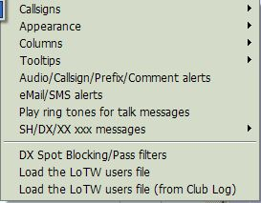

DXSW_26

This will bring up a pane where you can update the current list by clicking on the <**Download**> button and then the <**Save data**> button. The Config menu item allows the user to change the name and data for a different list.

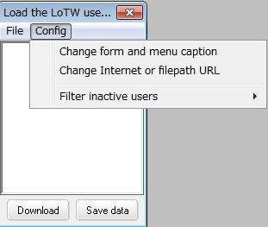

DXSW_27

Selecting the Change form and menu caption menu item will bring up another dialog box. Enter the name of the list: Example: LoTW users, eQSL users, etc.

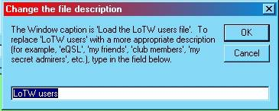

DXSW_28

Once you select the name, the you need to define the source for the user list. By selecting the "Change Internet or file path URL" menu item. This brings up a window where you can enter the Internet address or local file path. Follow the appropriate format example shown on the window.

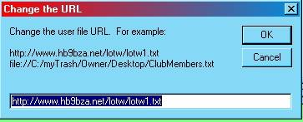

DXSW_29

Once the user has established the Name and URL, Select the <**Download**> button and wait until the window populates, then select the <**Save data**> button.

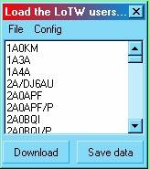

DXSW_30

**Load eQSL user file**

If the user prefers to indicate the callsign is a user of eQSL, then download the eQSL user file, follow the above process and name the file "eQSL user" and enter the following URL to download the eQSL file.

http://www.eqsl.cc/qslcard/DownloadedFiles/AGMemberList.txt

**NOTE**: Only one database can be active at a given time.

### ~~2.9.10~~ 2.10.10 Load LotW user file from Club Log

To download the LoTW users file from Club Log, right click on the DX Spot Window, left Click SETUP | LOAD LOTW USERS FILE (from Club Log) This file contains not only callsign but more recent LoTW upload date, more recent Club Log upload date, status of OQRS user or not and Grid Square. Club Log updates this file once a week (on Sunday UTC).

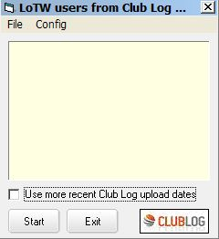

DXSW_30A

Logger32 shows LoTW user and/or OQRS user on DX Spot Window, BandMap and Logbook Page Window. If you prefer it shows LoTW/OQRS user based on recent Club Log upload date instead of recent LoTW upload date. Check “Use more recent Club Log upload date” in this case.

Click “Start” to download the file.

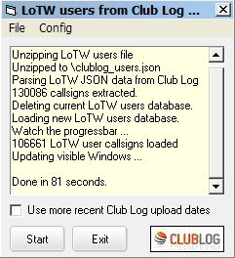

DXSW_30B

The downloaded file is saved as clublog_users.json in the Logger32 folder. The following is a part of the json file.

{"call":"JA1NLX","firstqso":"1963-02-28 08:00:00","lastqso":"2017-05-23 09:24:40","lastupload":"2017-05-23 10:01:01","locator":"PM95SM","oqrs":"true","last-lotw":"2017-05-18 02:26:05"},

Click “Config” to select more option.

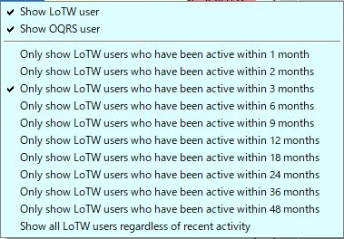

DXSW_30C

The special tips is displayed on DX Spot Window, BandMap. and Logbook Entry Window. Select the LoTW/OQRS user’s mark in each window.

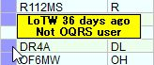

DXSW_30D

Tooltips are displayed in different styles depending on your settings. Some examples below.

If both “Show LoTW users” and “Show OQRS users” options are checked then tooltips are displayed in 2 lines, upper for LoTW user and lower for OQRS user. See DXSW_30D.

If either of these options is checked then tooltips are displayed in 1 line. (LoTW info or OQRS info) Example with “Show LoTW user” checked below.



DXSW_30E

Example with “Show OQRS user” checked below.



DXSW_30F

**Clicking DX Spot**

If Club log knows the Grid Square of a user, when you click on a DX Spot of that user, the Grid Square automatically populates the Grid Square field in the Logbook Entry Window (if Logger32 has not already found the Grid Square elsewhere).

## 3.0 DX SPOT HISTORY

The DX Spot History buffer holds a running history of DX Spots that have been selected by the operator. These can be displayed in DX Spot history table. To display the DX Spot history, go to the Logger32 Main menu View menu item and select Show DX Spot History menu item from the list..

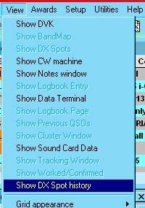

DXSW_31

The following is an example of a DX Spot History table showing 20 DX Spots that have been selected by the operator. The operator can elect to click on any spot listed in the History chart. This will result in the Logbook Entry window being filled just as it is with a spot from the DX Spot window. The selected spot will be highlighted with a yellow background as shown in the sample table. This is especially useful when DX Spots are coming in too fast to scroll back. The buffer holds the last 20 spots selected. The newest is displayed at the bottom of the table and as new ones are added, the spots will scroll up. Once the buffer is full the top spot will scroll off as new ones are added.

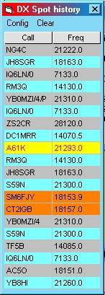

DXSW_32

In Addition to the DX Spot History, this function can also be configured to show where the radio was before the spot was selected. On the Spot history chart, select the Config | Show before DX Spot table menu items. The Show colored DX Spots menu item will display the spots highlighted as selected in the DX Spot window setup. There are also options to show tooltips and enter the callsign from the previous DX Spot.

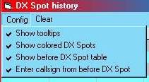

DXSW_33

Following is an example of both tables. The operator can click on a listing in the B4 table, but it will only reset the radio to the frequency indicated and will not fill the call and other fields. This is useful to reset the radio to a frequency that was being monitored before clicking on a DX Spot. There are also options to show tooltips and enter the callsign from the previous DX Spot.

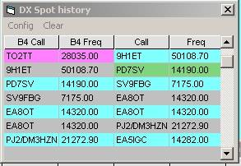

DXSW_34